GISBORNE PRESBYTERIAN PARISH

Matawhero Church – Church Lane

St Andrew’s Church and Community Centre:

7176 Cobden Street, Gisborne

SUNDAY 28 APRIL, 2024
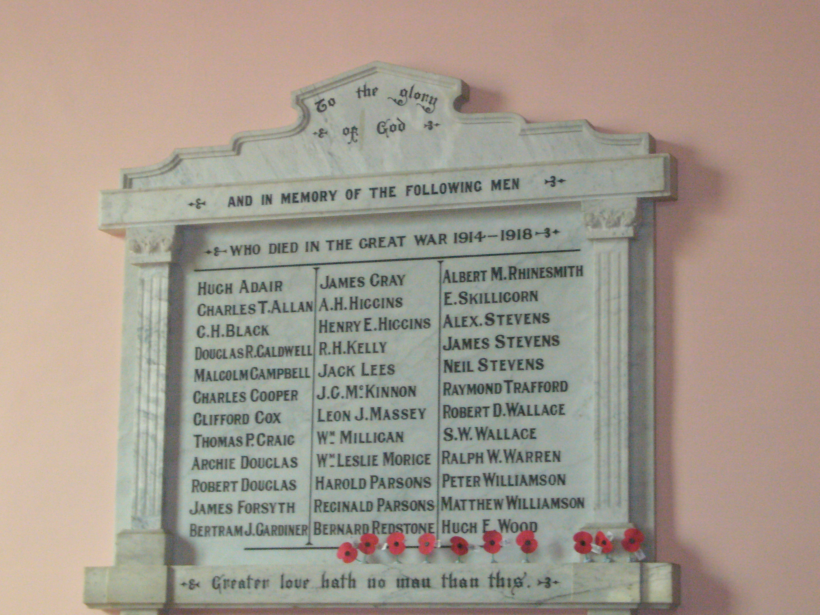

Ministers: All the people
Liturgist Beverley Smith
Readers: Bob Bos/Pat Flockhart
Organist: David Russell

We welcome all visitors to our service this morning.
Please sign the Visitors’ Book and make yourself known to the Hosts who stand at the back of the church. A toilet is located in the foyer.
In our worship we use inclusive language as much as possible. Sometimes, especially in the hymns, this is not possible. Feel free to insert the language with which you are most comfortable.
BOLDED WORDS are for congregational response.
Where there is an asterisk * please stand.
Welcome and Notices Pat Flockhart
Silent Preparation

Introit: CH4 346

Alleluia Alleluia, Alleluia, Alleluia!

The Word of the Lord lasts for ever,
What is the Word that is living?
It is brought to us through his Son Jesus Christ.

Alleluia Alleluia, Alleluia, Alleluia!

The Word of the Lord is alive,
The Word of God is active –
It can judge our thoughts, bring us closer to the Father.

Alleluia Alleluia, Alleluia, alleluia!

GATHERING

We gather in the shadow of 100 years of war memories,
In the shadow of 100 years of efforts for peace.
We gather in the name of a God whose will is justice,
In the name of a Christ who strove for true peace.
We gather in the presence of the Spirit whose image is a dove.
In each other’s presence, may our name be Love.

PRAYER OF APPROACH Pat Flockhart
ader: The world belongs to God
All: The earth and all its people
Leader: How good and lovely it is
All To live together in unity
Leader: Love and faith come together
All: Justice and peace join hands
Leader: If the Lord’s disciples keep silent
All: These stones would shout aloud
Leader: Open our lips O God
All: And our mouths shall proclaim your presence.

*Hymn AA155

Where mountains rise to open skies
your name, O God, is echoed far,
from island beach to kauri’s reach,
in water’s light, in lake and star.

Your people’s heart, your people’s part

Be in our caring for this land,

For faith to flower, for aroha

To let each other’s mana stand.

From broken word, from conflict stirred,

From lack of vision, set us free

To see the line of your design,

To feel creation’s energy.

Your love be known, compassion shown,

That every child have equal scope:

In justice done, in trust begun

Shall be our heritage and hope.

Where mountains rise to open skies

Your way of peace distil the air,

Your spirit bind all humankind,

One covenant of life to share! Shirley Murray

PRAYER FOR PEACE
God blesses those who work for peace,
For they will be called the children of God. (Matt5:9)
Silence
God of peace you call us to peace
Peace within and peace without
Peace before and peace behind
Peace on right and peace on left
Christ of peace you call us to peace.
Peace with brother and with sister
Peace with neighbour and with stranger
Peace with friend and with foe.
Spirit of peace you call us to peace.
Peace in work and in play
Peace in thought and in deed
Peace in word and in action
Grant us peace O God of peace. Amen

Isaiah 2:3-5 Pat Flockhart
John 14:23-27
Contemporary Reading:- Poem –Margaret Copland

RESPONSE
For the word of God in scripture and story
For the word of God among us
For the word of God within us,
We give thanks

Anzac Reflection: Bob Bos

Commemoration – we honour our very own servicemen Please stand: Bob continues

“The Last Post” - Please stand
ODE of REMBRANCE: They shall not grow old,
ALL: as we that are left grow old;
Age shall not weary them,
nor the years condemn.
At the going down of the sun
and in the morning
We will remember them.
Reveille

The story of Rev’d Ormond Burton Bob Bos

Anthem: St. Francis. Make me a channel of Thy Peace Choir Pat

Offering & Dedication: Pat

Nun Danket CH4 182
Now thank we all our God with hearts and hands and voices,
who wondrous things hath done, in whom his world rejoices:
who from our mothers’ arms hath blest us on our way
with countless gifts of love, and still is ours today.
Dedication:
All: We give thanks for all we have been given
We give thanks for all we have enjoyed of food and goods and freedom, entertainment and recreation, access and knowledge.
We bring with gratitude food and money with which
We have been entrusted so others may benefit
And this place may go forward in the name of Love
May we use wisely what we have retained
So all we have honours the name of Love and benefits our world.
AMEN

Hymn: HS 61
Honour the dead, our country’s fighting brave,
Honour our children left in foreign grave,
Where poppies blow and sorrow seeds her flowers,
Honour the crosses marked forever ours.

Weep for the places ravaged by our blood,
Weep for the young bones buried in the mud,
Weep for the powers of violence and greed,
Weep for the deals done in the name of need.

Honour the brave whose conscience was their call,
Answered no bugle, went against the wall,
Suffered in prisons of contempt and shame,
Branded as cowards, in our country’s name.

Weep for the waste of all that might have been.
Weep for the cost that war has made obscene,
Weep for the homes that ache with human pain,
Weep that we ever sanction war again.

Honour the dream for which our nation bled,
Held now in trust to justify the dead,
Honour their vision on this solemn day:
Peace known in freedom, peace the only way.
Words Shirley Murray, Music Colin Gibson.

PRAYER Pat
An Act of remembrance and Prayer
Let us pray for all who suffer as a result of conflict, and ask that God may give us peace.
For the servicemen and women who have died in the violence of war, each one known to God, may God give peace.
God give peace

For all members of the armed forces who are in danger this day,
Remembering family, friends and all who pray for their safe return, may God give peace.
God give peace

For civilian women, children and men whose lives are disfigured by war or terror, calling to mind in penitence the anger and hatreds of humanity, may God give peace.
God give peace

For peace-makers and peace-keepers, who seek to keep this world secure and free, may God give peace.
God give peace

For all Defence Force chaplains offering support, encouragement, acceptance, compassion and understanding, wherever and whenever it is needed, may God give peace.
God give peace

For all who bear the burden and privilege of leadership – political, military and religious; and for all who seek wisdom and resolve in the search for reconciliation, may God give peace.
God give peace

O God of truth and justice,
We hold before you those whose memory we cherish,
And those whose names we will never know.
Help us to life our eyes above the torment of this broken world,
And grant us the grace to pray for those who wish us harm.
As we honour the past, may we put our faith in your future;
For you are the source of life and hope, now and for ever.
Amen. (Source: Uniting Church in Australia)

Hymn: Let there be peace on earth Pat
Let there be peace on earth and let it begin with me;
Let there be peace on earth, the peace that was meant to be
With God as our Maker, a family are we
Let us all walk together in perfect harmony.

Let peace begin with me, let this be the moment now.
With ev’ry step I take, let this be my solemn vow:
To take each moment,
and live each moment, in peace eternally.
Let there be peace on earth and let it begin with me.

Blessing: Bob Bos
Blessed are those who come in peace
Who fought then and fight now for peace with justice
Go in peace and spread peace wherever you go.
We go in peace to spread peace wherever we go,
Peace founded on truth and justice and formed by Love.

SUNG AMEN

Acknowledgement and appreciation to Beverley Smith for allowing us to use this service which she prepared for ANZAC in 2016. She included thanks to Rev.Dr Allan Davidson & Rev. Keith Lowe for sharing their research for this service.

Please join us for a time of fellowship and friendship in the lounge of the Community Centre next door for a cup of tea or coffee

Note: The offering is now received at the door as we enter. If you miss noticing this, you may place a retiring offering in the offering boxes at the door as you leave.

Mindful Prayer topics: April 21st & 28th 2024 Remembering our ANZAC's and those suffering in current conflicts. World Peace. Those recovering from major surgery. Peace to those who are troubled or face the loss of a loved one. “May you see the face of Christ in every one you meet, and may everyone you meet see the face of Christ in you”. (From a Celtic Prayer)
.Mindful Prayer contact Margaret Graham ph. 021 026 03990 or email m.n.e.gra@xtra.co.nz

Christian Blind Mission accepts used stamps. Send directly to them or Val Hall. (Leprosy Mission no longer accepts stamps)
Please remember donations for the Love basket when shopping. All offerings gratefully received.

Val Hall and Pat Flockhart are offering Home Communion, and they need an Elder to be present. Any Elders willing to assist, please phone or email Val Hall.
For all Pastoral care needs please contact one of the committee members:
Jenny Lawton 868 4268; Ruth McLennan 021 02704867; Jan Gordon 0211836008 Annette Ormiston 0275535028 Barbara Larsen 863-9009
With blessings from the Pastoral Committee
DIARY

SUNDAY 28 EASTER 5 ANZAC Autumn School Hols (3)
10.00am St Andrew’s
Matawhero - No service
3.00pm Sea of Faith
Monday 29 9.00am Walking Group
Tuesday 30 10.00am Open Door All welcome
12.00noon Worship Committee
Wednesday 1 9.45am mainly music
Friday 3 1.00pm Choir Practice
Saturday 4 8-11.30am Car Boot Sale

SUNDAY 5 EASTER 6 Communion Celebrant Pat Flockhart
10.00am Matawhero Lynnor Cooke
St Andrew’s - No service
Coming up: Saturday 18 May 10am-3pm Leadership Workshop at St Andrew’s
Led by Knox Centre for Ministry and Leadership, Presbytery Central

Sunday | Reader | Door & Team | Morning Tea | Sound Visual
28 April Easter 5  ANZAC  Continuity Pat Flockhart | Matawhero  No service  St Andrew’s  Bob Bos | Seton Clare Marilyn Matthews  Alvin Hall | Lapointe Family | S: Hans  V: Don  C: Hans
5 May Easter 6  Communion  Celebrant Pat Flockhart  Lynnor Cooke | Matawhero  Communion  St Andrew’s  Bev Kirkpatrick | Matawhero Team | Matawhero Team,  Contributions welcome | N/A

Gisborne Presbyterian Parish
St Andrew’s Church and Matawhero Historic Church:
Office: 06 868 5513 Hours 10-12 Tuesday – Thursday
176 Cobden Street 4010 Bank A/c number 03-0638-0462917-000
standrewsgisb@xtra.co.nz www.standrewsgis.org.nz

