GISBORNE PRESBYTERIAN PARISH

Matawhero Church – Church Lane

St Andrew’s Church and Community Centre:

176 Cobden Street, Gisborne

5 April 2026 Easter Day

Welcome to all visitors on this special Festival day,

Especially the Rev Michael Cotton,

And Lynne Cotton, on organ and piano

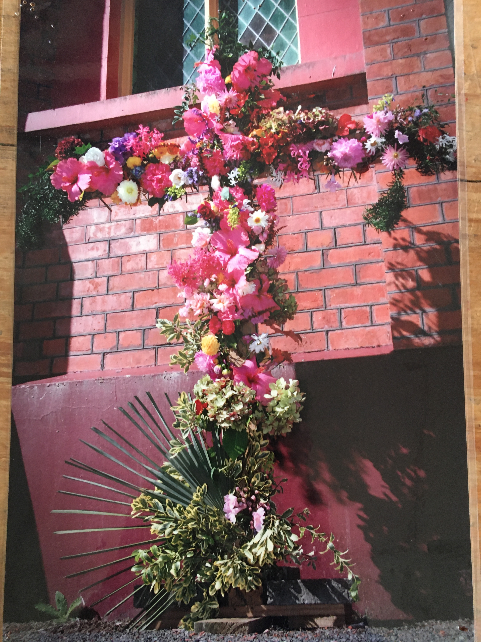

We welcome all visitors to our service this morning.
Please sign the Visitors’ Book and make yourself known to the Hosts who stand at the back of the church. A toilet is located in the foyer.
In our worship we use inclusive language as much as possible. Sometimes, especially in the hymns, this is not possible. Feel free to insert the language with which you are most comfortable. BOLDED WORDS are for congregational response.
Where there is an asterisk * please stand.

Preamble Mike
Leader: The Lord is risen: Alleluia!
All: He is risen indeed. Alleluia!

Welcome, news and Notices

Introit, entry of Bible and lighting of candles Alleluia WA Mozart

Call to Worship: Psalm 118 14-24 New International Version
The Lord is my strength and my defence,
he has become my salvation.
Shouts of joy and victory resound in the tents of the righteous:
“The Lord’s right hand has done mighty things!
The Lord’s right hand is lifted high;
the Lord’s right hand has done mighty things!”
I will not die but live, and will proclaim what the Lord has done.
The Lord has chastened me severely,
but he has not given me over to death.
Open for me the gates of the righteous;
I will enter and give thanks to the Lord.
This is the gate of the Lord
through which the righteous may enter.
I will give you thanks, for you answered me;
you have become my salvation.
The stone the builders rejected has become the cornerstone;
the Lord has done this, and it is marvellous in our eyes.
The Lord has done it this very day; let us rejoice today and be glad.

We sing:- Sing praise to the Lord PCC 107
1 Sing praise to the Lord! Sing praise in the height
rejoice in God’s word, all angels of light:
Now worship your Maker by whom you were made,
adore your Creator in brightness arrayed.
2 Sing praise to the Lord; sing praise on the earth
in tuneful accord, you heirs of new birth:
praise God who has brought you rich grace from above;
praise God who has taught you with mercy and love.
3 Sing praise to the Lord! all things that give sound,
each jubilant chord re-echo around:
loud organs, God’s glory proclaim in deep tone,
and sweet harp, the story of what God has done.
4 Sing praise to the Lord! thanksgiving and song
to God be outpoured all ages along:
for love in creation, for heaven restored,
for grace of salvation, sing praise to the Lord!

Opening prayer

Reading Acts 10:34-43 New International Version
³⁴ Then Peter began to speak: “I now realize how true it is that God does not show favouritism ³⁵ but accepts from every nation the one who fears him and does what is right. ³⁶ You know the message God sent to the people of Israel, announcing the good news of peace through Jesus Christ, who is Lord of all. ³⁷ You know what has happened throughout the province of Judea, beginning in Galilee after the baptism that John preached— ³⁸ how God anointed Jesus of Nazareth with the Holy Spirit and power, and how he went around doing good and healing all who were under the power of the devil, because God was with him.
³⁹ “We are witnesses of everything he did in the country of the Jews and in Jerusalem. They killed him by hanging him on a cross, ⁴⁰ but God raised him from the dead on the third day and caused him to be seen. ⁴¹ He was not seen by all the people, but by witnesses whom God had already chosen—by us who ate and drank with him after he rose from the dead. ⁴² He commanded us to preach to the people and to testify that he is the one whom God appointed as judge of the living and the dead. ⁴³ All the prophets testify about him that everyone who believes in him receives forgiveness of sins through his name.”

Hymn: “Christ is made the sure Foundation” CH4 200 ((Regent Square tune 110)
Christ is made the sure foundation,
Christ the head and corner-stone,
chosen of the Lord and precious,
binding all the Church in one,
holy Zion’s help for ever
and her confidence alone.

To this temple, where we call you,
come, O Lord of Hosts, today:
with your constant loving-kindness,
hear your servants as they pray,
and your fullest benediction
shed within its walls alway.

Here bestow on all your servants
what they ask of you to gain,
what they gain from you for ever
with the blessed to retain,
and hereafter in your glory
evermore with you to reign.

Praise and honour to the Father,
praise and honour to the Son,
praise and honour to the Spirit,
ever Three and ever One,
One in might and One in glory
while unending ages run. Written 7th or 8th Century
A Reading from the Gospel of Luke chapter 24 verses 1-12 NIV
Jesus Has Risen
24 On the first day of the week, very early in the morning, the women took the spices they had prepared and went to the tomb. ² They found the stone rolled away from the tomb, ³ but when they entered, they did not find the body of the Lord Jesus. ⁴ While they were wondering about this, suddenly two men in clothes that gleamed like lightning stood beside them. ⁵ In their fright the women bowed down with their faces to the ground, but the men said to them, “Why do you look for the living among the dead? ⁶ He is not here; he has risen! Remember how he told you, while he was still with you in Galilee: ⁷ ‘The Son of Man must be delivered over to the hands of sinners, be crucified and on the third day be raised again.’ ” ⁸ Then they remembered his words.
⁹ When they came back from the tomb, they told all these things to the Eleven and to all the others. ¹⁰ It was Mary Magdalene, Joanna, Mary the mother of James, and the others with them who told this to the apostles. ¹¹ But they did not believe the women, because their words seemed to them like nonsense. ¹² Peter, however, got up and ran to the tomb. Bending over, he saw the strips of linen lying by themselves, and he went away, wondering to himself what had happened.

Sermon Mike

Prayers of Intercession Paulina Melief
Lord’s Prayer (sung)
Our Father in heaven, hallowed be your Name,
your kingdom come, your will be done,
on earth as in heaven.
Give us today our daily bread.
Forgive us our sins as we forgive those who sin against us.
Save us from the time of trial and deliver us from evil.
For the kingdom, the power, and the glory
are yours now and forever. Amen (x8)
Presentation of Offerings and Flowered Cross
Dedication: Mike

Communion Hymn “Come down O love divine” (Down Ampney 66 11 D ) CH4 489

Come down, O Love Divine,
seek out this soul of mine,
and visit it with your own ardour glowing;
O Comforter, draw near,
within my heart appear,
and kindle it, your holy flame bestowing.

O let it freely burn,
till earthly passions turn
to dust and ashes, in its heat consuming;
and let your glorious light
shine ever on my sight,
and clothe me round, the while my path illuming.

Let holy charity
my outward vesture be,
and lowliness become my inner clothing;
true lowliness of heart,
which takes the humbler part,
and o’er its own shortcomings weeps with loathing.

And so the yearning strong,
with which the soul will long,
shall far outpass the power of human telling;
we cannot guess its grace,
till we become the place
wherein the Holy Spirit makes a dwelling.

Communion
Communion Liturgy C page 10

We sing: Thine be the Glory CH4 419
Thine be the glory, risen, conquering Son,
endless is the victory thou o’er death hast won;
angels in bright raiment, rolled the stone away,
kept the folded grave-clothes, where thy body lay.
Thine be the glory, risen, conquering Son,
endless is the victory thou o’er death hast won.

Lo! Jesus meets us, risen from the tomb;
lovingly he greets us, scatters fear and gloom;
let the Church with gladness hymns of triumph sing,
for her Lord now liveth; death hath lost its sting.

No more we doubt thee, glorious Prince of Life;
life is naught without thee: aid us in our strife;
make us more than conquerors, through thy deathless love:
bring us safe through Jordan to thy home above.

Final Prayer
Blessed be God who calls us together.
Praise to God who makes us one people.

Blessed be God who has forgiven our sin.
Praise to God who gives hope and freedom.

Blessed be God whose Word is proclaimed.
Praise to God who is revealed as love.

Blessed be God who alone has called us.
Therefore we offer all that we are
and all that we shall become.

Accept, O God, our sacrifice of praise.
Amen. Accept our thanks for all you have done.
Our hands were empty, and you filled them.

Mike – Blessing and Dismissal

Sung:- Three fold Amen

Ministers: All the people in Christ
Leader: Rev. Michael Cotton Reader: Bob Bos
Communion celebrant: Pat Flockhart
Prayer: Pauliina Melief Organist: Lynne Cotton

Please join us for friendship and fellowship and a cup of tea or coffee in the lounge after the service

Note: The offering is now received at the door as we enter. If you miss noticing this, you may place a retiring offering in the offering boxes at the door as you leave.
Please remember donations for the Love basket when shopping. All offerings gratefully received.
Mindful Prayer topics: April 5th & 12th 2026 World Peace. Natural disasters. GPP as we move towards dissolution. “One thing I know that in your death and resurrection, new life is grafted on to old, and I am content to leave all future growth with you” (Eddie Askw – Encounters)
Mindful Prayer contact Margaret Graham ph. 021 026 03990 or email m.n.e.gra@xtra.co.nz
Christian Blind Mission accepts used stamps. Send directly to them or Val Hall.
Matawhero Gardening happens from time to time. If you would like to help, please contact Paulina Melief 867 0605

The Pastoral Care Committee realises that they are not hearing about some pastoral care issues, for example parishioners in hospital or otherwise ill. They ask the congregation to be proactive in telling the committee or getting families to alert them so they can provide visitors or other care for our members. For all Pastoral care needs please contact one of the committee members: Jenny Lawton 868 4268; Ruth McLennan 021 02704867; Jan Gordon 0211836008; Lynnor Cooke 06 214 3945; Barbara Larsen 863-9009

King’s Birthday Weekend Celebrations

Programme outline

29th May Friday
5-7:00pm Opening & Welcome - St Andrews, Memorial Hall

30th May Saturday
10-12md visit to Matawhero Historic Church, historic display and talk
12:30 pm luncheon at Bushmere Arms
7:00 pm solo theatre performance - St Andrews Church

31st May Sunday
10:00am Special Service of Thanksgiving - St Andrews
Church
Refreshments to follow - St Andrews, Memorial Hall

1st June Monday
12:30pm Piano Extravaganza - St Andrews Church

DIARY for this week in April
April 5 Lent 5 Easter Day NZ Standard time begins Floral Transforming of the Cross Autumn School Hols begin communion cloths on the pews for Easter Sunday
Matawhero – No service
10am St. Andrew’s– Rev Mike Cotton
Tuesday 7 10am Open Door All welcome
Wednesday 8 3pm Te Wiremu
Friday 10 1pm Choir rehearsal tbc
Saturday 11 8.00am – 11.30 CAR BOOT SALE

April 12 Easter 2 Autumn School Hols (2)
10am St. Andrew’s– Rev Ken Wall
Matawhero – No service
Sunday | Reader | Door & Team | Morning Tea | Sound Visual
12 January  Epiphany 1  Sr Cynthia Kearney | Matawhero  No service  St Andrew’s  Alvin Hall | Seton Clare  Dianne Burrows | Lyn Griffiths | S&V: Don  C:Don
Easter Day 5th April Rev. Mike Cotton | M:  St A’s: Bob Bos | Don McConnochie  Sarah McC | Lyn Griffiths | S&V: Linda  C: Don
Sunday 12th April  Rev Ken Wall | M: No service  St A’s: | Chrissie Parker  Cathy Porter | Ruth McLennan | S&V: Don  C: Don

Easter Communion – Celebrant: Pat Flockhart; Don McC;
Val Hall; Cathy Porter, Jan Gordon

Gisborne Presbyterian Parish
St Andrew’s Church and Matawhero Historic Church:
Office: 06 868 5513 Hours 10-12 Tuesday – Thursday
176 Cobden Street 4010 Bank A/c number 03-0638-0462917-000
standrewsgisb@xtra.co.nz www.standrewsgis.org.nz

