GISBORNE PRESBYTERIAN PARISH

Matawhero Church – Church Lane

St Andrew’s Church and Community Centre:

176 Cobden Street, Gisborne

www.standrewsgis.org.nz

30 November 2025 Advent 1

Christmas Unwrapped

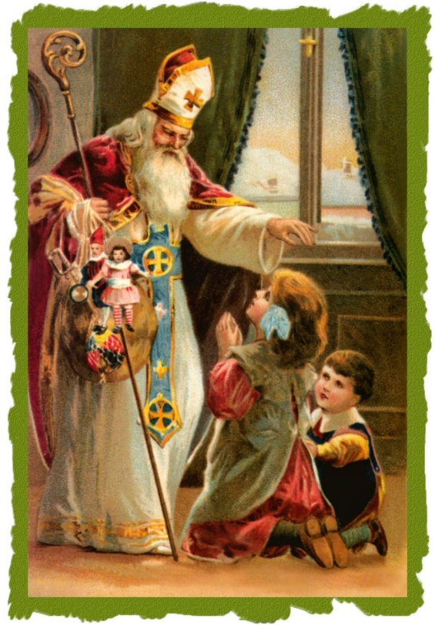
There is an old adage that goes “’Tis far better to give than to receive”, and no time of the year is this more poignant than at Christmas time. But who gave us the magic that is Christmas, and how did it come to be a season for celebration, compassion and giving, when old records dictate that it was once a simple pagan festival, and Father Christmas was a saint?
We welcome all visitors to our service this morning.
Please sign the Visitors’ Book and make yourself known to the Hosts who stand at the back of the church.
A toilet is located in the foyer.
In our worship we use inclusive language as much as possible. Sometimes, especially in the hymns, this is not possible. Feel free to insert the language with which you are most comfortable.
*Please feel free to sit for the hymns if that is more comfortable for you*
BOLDED WORDS are for congregational response.

Prelude
Welcome, News and Information Ruth
Call for Silence

Introit and entry of the Bible, anticipating the light of Christ among us

Light of lights beholden
we from days of olden
sang this song
for to understand
that peace upon this planet
was pledged to come.
Each to other, sister, brother,
born for life and song.

look towards the light and carry on:
let the simple heart and hope among us
keep our family strong,
let the simple heart and hope among us
keep our family strong.

Darkness all around us,
light has always found us,
light will come
where the dark is deepest,
greater light will keep us
safe from harm.
Troubled times will always find
a voice of troubled doom,

Call to Worship Ruth
Leader: In the beginning was the Word

All: and the Word was with God

and the Word was God
Leader: He was with God in the Beginning

All: Through Him all things were made
Leader: In him was life and that life was the light for all people

All: In the beginning was Wisdom

Leader: and Wisdom was with God
and Wisdom was God.
All: She was in the beginning with God
Leader: All things came into being through her.

All: In her was life and the life was the light for all people
Leader: The light shines in the darkness and the darkness has not overcome it

All: Jesus Christ is the light of the world
Leader: Wisdom is a reflection of eternal light, a spotless mirror of the working of God, and an image of God’s goodness. (Wisdom 7:26)
All: Praise God who sends us the light of heaven.

*Hymn: CH4 112 Moscow

God, whose almighty word
chaos and darkness heard,
and took their flight;
hear us, we humbly pray,
and, where the gospel-day
sheds not its glorious ray,
let there be light.

Saviour, who came to bring,
on your redeeming wing,
healing and sight,
health to the sick in mind,
sight to the inly blind,
now to all humankind
let there be light.
Spirit of truth and love,
life-giving, holy dove,
Speed forth your flight;
move o’er the waters’ face,
bearing the lamp of grace,
and in earth’s darkest place
let there be light.

Blessed and holy Three,
glorious Trinity,
Wisdom, Love, Might,
boundless as ocean‘s tide
rolling in fullest pride,
through the world far wide
let there be light.

Lighting the candle of Hope liturgy by Angela Blundell Catherine M
In the very middle of the fern, in its damp, moist belly a koru emerges reaching to the light, offering a sign of rejuvenation and birth. Even when a fern appears dead and lifeless, tiny koru can be found, offering the promise of hope and life.
As we light the green candle nestled amongst the fern we anticipate the hope of new life in the birth of Jesus Christ.
God of hope
As the koru unfurls within the centre of the fern
Give us the hope of new life found within an innocent child
Help us to carry this hope in this Advent season
Knowing that amongst our sin and weakness
There is hope and renewal to be found in your Son Jesus Christ, Amen

Christmas and Light Chrissie

Hymn: Let there be light WB 35
Let there be light
let there be understanding,
let all the nations gather,
let them be face to face.

- Open our lips,
open our minds to ponder,
open the door of concord
opening into grace.

- Perish the sword,
perish the angry judgement
perish the bombs, and hunger,
perish the fight for gain.

- Hallow our love,
hallow the deaths of martyrs,
hallow their holy freedom,
hallowed be your name.

- Let there be light,
open our hearts to wonder,
perish the way of terror,
hallow the world God made. Frances Wheeler Davis

Readings Genesis 1:1-3 New International Version Ruth
1 In the beginning God created the heavens and the earth. ² Now the earth was formless and empty, darkness was over the surface of the deep, and the Spirit of God was hovering over the waters.
³ And God said, “Let there be light,” and there was light.
John 8: 12 New International Version
¹² When Jesus spoke again to the people, he said, “I am the light of the world. Whoever follows me will never walk in darkness, but will have the light of life.”
John 12: 36 New International Version
³⁶ Believe in the light while you have the light, so that you may become children of light.” When he had finished speaking, Jesus left and hid himself from them.

Hymn: People look East CH4 281
People, look East. The time is near of the crowning of the year.
Make your house fair as you are able, trim the hearth and set the table.
People, look East, and sing today: Love, the Guest, is on the way.
Furrows, be glad. Though earth is bare,
one more seed is planted there:
give up your strength the seed to nourish,
that in course the flower may flourish.
People, look East, and sing today:
Love, the Rose, is on the way.

Birds, thou ye long have ceased to build,
Guard the nest that must be filled.
Even the hour when wings are frozen
He for fledging time has chosen
People look East and sing today:
Love, the Bird, is on the way.

Stars, keep the watch. When night is dim
one more light the bowl shall brim,
shining beyond the frosty weather,
bright as sun and moon together.
People, look East, and sing today:
Love, the Star, is on the way.

Angels, announce with shouts of mirth
Christ who brings new life to earth.
Set every peak and valley humming
with the word, the Lord is coming.
People, look East, and sing today:
Love, the Lord, is on the way.

Christmas and Traditions Jan E

*Hymn: Tune: Quelle est cette odeur agréable CH4 318
Praise we the God who made all beauty
for all our senses to enjoy:
give we our humble thanks and duty
that simple pleasures never cloy:
praise we the God who made all beauty
for all our senses to enjoy.

Praise God who makes our life a pleasure,
sending us things which glad our eyes;
thanks to the One who gives us leisure,
that in our heart sweet thoughts may rise;
praise God who makes our life a pleasure,
sending us things which glad our eyes.

Praise God who by a simple flower
lifts up our hearts to things above;
thanks to the one who gives us power
to find a friend to know and love:
praise God who by a simple flower
lifts up our hearts to things above.

Christmas and Carols Val

*Hymn: CH4 294
On Christmas night all Christians sing,
to hear the news the angels bring,
On Christmas night all Christians sing,
to hear the news the angels bring,
news of great joy, news of great mirth,
news of our merciful King’s birth.

Then why should we on earth be so sad,
since our redeemer made us glad,
Then why should we on earth be so sad,
since our redeemer made us glad,
when from our sin he set us free,
all for to gain our liberty?

All out of darkness we have light,
which made the angels sing this night:
All out of darkness we have light,
which made the angels sing this night:
Glory to God, on earth be peace,
Goodwill to all shall never cease!
Prayers of the People Margaret
Leader: Jesus, the light of the world
All: Love came down at Christmas

Offering: Ruth

Christmas and the Virgin Birth Pat

Anthem: O viridissima virga – Hildegard of Bingen

Christmas and the Crib Trish

*Hymn: Tell out my soul Woodlands CH4 286

- Tell out, my soul, the greatness of the Lord!
Unnumbered blessings, give my spirit voice;
tender to me the promise of his word;
in God my Saviour shall my heart rejoice.

- Tell out, my soul, the greatness of God’s Name!
Make known God’s might, the deeds God’s arm has done;
God’s mercy sure, from age to age the same;
God’s holy Name – the Lord, the Mighty One.

- Tell out, my soul, the greatness of God’s might!
Powers and dominions lay their glory by.
Proud hearts and stubborn wills are put to flight,
the hungry fed, the humble lifted high.

- Tell out, my soul, the glories of God’s word!
Firm is God’s promise, and God’s mercy sure.
Tell out, my soul, the greatness of the Lord
to children’s children and for evermore!

Blessing: Pat
The manger of course seems empty,
but no! it is waiting
and as we await the re-enactment of the Christmas story
let us go in peace and expectation with
the wisdom of the Wonderful Counsellor to guide us,
the strength of the Mighty God to uphold us,
the love of the Everlasting Father to embrace us
and may peace from the Prince of Peace be upon us.

All: Sing 3-fold Amen during which Bible Exits

Postlude

Ministers: All the people
Leaders: Ruth McLennan, Catherine Macdonald, Chrissie Parker, Jan Ewart, Val Hall, Margaret Graham, Pat Flockhart, Trish Groves
Organ: Paul Pollock

Please join us for friendship and fellowship and a cup of tea or coffee in the lounge after the service

Note: The offering is now received at the door as we enter. If you miss noticing this, you may place a retiring offering in the offering boxes at the door as you leave.
Please remember donations for the Love basket when shopping. All offerings gratefully received.

For all Pastoral care needs please contact one of the committee members:
Jenny Lawton 868 4268; Ruth McLennan 021 02704867; Jan Gordon 0211836008; Lynnor Cooke 06 214 3945; Barbara Larsen 863-9009
Christian Blind Mission accepts used stamps. Send directly to them or Val Hall.
Matawhero Gardening happens from time to time. If you would like to help, please contact Paulina Melief 867 0605
Mindful Prayer topics: Nov 16th & 23rd 2025 Conflict and victims. Health. Recovery from natural disasters. The bereaved. Uncertainty.
“Above the winds, hear me; Upon the sea, hold me; On lonely isle, love me; In dark night, enfold me” Joyce Denham

Mindful Prayer contact Margaret Graham ph. 021 026 03990 or email m.n.e.gra@xtra.co.nz

DIARY for this week in November nnd December

LITURGICAL NEW YEAR
Sunday 30 ADVENT 1 St Andrew’s Day
10.00am St. Andrew’s
Matawhero – No service

Tuesday 2 10.00am Open Door
7.00pm Lessons and Carols Choir rehearse
Wednesday 3 9.45am mainly music
Friday 5 1.00pm Choir rehearsal tbc

SUNDAY 7 ADVENT 2 10.00am Matawhero Communion Shirley B-K
Sunday | Reader | Door & Team | Morning Tea | Sound Visual
12 January  Epiphany 1  Sr Cynthia Kearney | Matawhero  No service  St Andrew’s  Alvin Hall | Seton Clare  Dianne Burrows | Lyn Griffiths | S&V: Don  C:Don
Sunday 30 November  Advent Sunday | M: No service  St A’s | Seton Clare  Dianne Burrows | Trish Kwak | S&V: Hans  C: Hans
Sunday 7 December  Shirley B-K  Communion Matawhero | M:  St A’s: No service | Matawhero Team | Matawhero Team | S&V: N/A  C: N/A
Communion Celebrant 7 December: Shirley Barker-Krby; Elders Jan Ewart, Barbara Larsen
Gisborne Presbyterian Parish
St Andrew’s Church and Matawhero Historic Church:
Office: 06 868 5513 Hours 10-12 Tuesday – Thursday
176 Cobden Street 4010 Bank A/c number 03-0638-0462917-000
standrewsgisb@xtra.co.nz www.standrewsgis.org.nz

