GISBORNE PRESBYTERIAN PARISH
WELCOME TO MATAWHERO HISTORIC CHURCH

Matawhero Church – Church Lane

St Andrew’s Church and Community Centre:

176 Cobden Street, Gisborne

29 June 2025 Pentecost 3
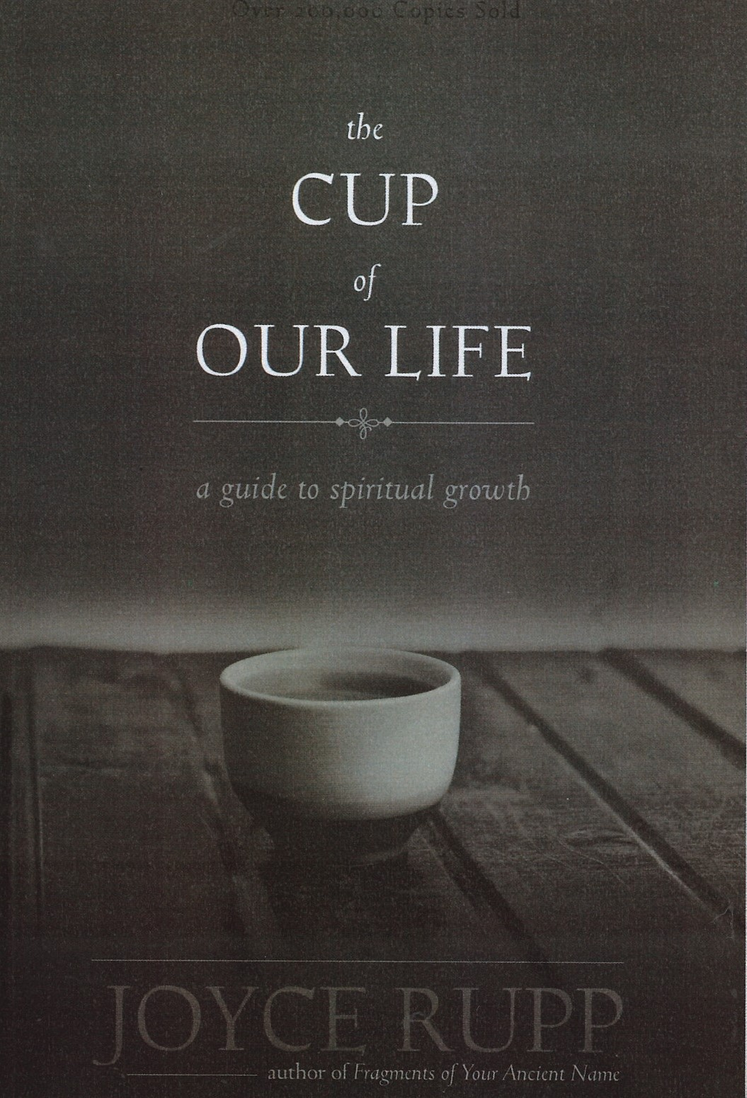

We welcome all visitors to our service this morning.
Please sign the Visitors’ Book and make yourself known to the Hosts who stand at the back of the church. A toilet is located in the hall.
In our worship we use inclusive language as much as possible. Sometimes, especially in the hymns, this is not possible. Feel free to insert the language with which you are most comfortable. BOLDED WORDS are for congregational response.
Where there is an asterisk * please stand.
The cup of our life
Introduction Pat
The Broken Cup
Prayer Pat
Reading Psalm 31:12 Reader
Reflection Pat
Poem reader
Love pours out but the broken cup cannot receive Too pained, too
discouraged, too shamed, too broken-hearted, too burned out, too
disenchanted.
Love waits to strengthen, love waits to nourish, love waits to be received,
Love waits to heal, in time the cup will be mended, in time, the cup will be
raised, in time the cup will receive again, in time, in time
Reading 2: John 12 :20-26 16:25-33. Reader
Prayer Pat
The Mended Cup
Reflection and prayer Pat
The Memory Cup
Reflection Pat
The cup of Thanksgiving
Reflection Pat
The Cup of Life
Prayer: All
Loving life giving God, you continuously pour your transforming love
Into the cup of our lives.
Like a spring rain falling Into the open soil,
your love and ours is mixed and mingled into an energising oneness.
Your presence is the power we need to grow and to change.
Your gift of love enables us to commit ourselves to the unending process of
spiritual transformation.
How grateful we are.
How ready to grow.

Ending and Blessing Pat

Ministers: All the people in Christ Leader: Pat Flockhart
Readers:
Please join us for a time of fellowship and friendship over a cup of tea or coffee in the Hall next door.
Note: The offering is now received at the door as we enter. If you miss noticing this, you may place a retiring offering in the offering boxes at the door as you leave.
Please remember donations for the Love basket when shopping. All offerings gratefully received.
For all Pastoral care needs please contact one of the committee members:
Jenny Lawton 868 4268; Ruth McLennan 021 02704867; Jan Gordon 0211836008; Lynnor Cooke 06 214 3945; Barbara Larsen 863-9009
Christian Blind Mission accepts used stamps. Send directly to them or Val Hall.
Matawhero Gardening happens from time to time. If you would like to help, please contact Paulina Melief 867 0605
June 29th & July 6th 2025 The world in turmoil. “From above, below, inside and outside, may peace bind us together”.(From a Maori Karakia). GPP; pray for guidance with decisions ahead. Those struggling with health and its side issues.
Mindful Prayer contact Margaret Graham ph. 021 026 03990 or email m.n.e.gra@xtra.co.nz
Commission contact: Commission Convenor Rob McIntosh email rob.mcintosh02@gmail.com, or Phone 0274411392 to arrange a time to talk further
DIARY for this week in June and July

SUNDAY 29 PENTECOST 3 Winter School Holidays start
10.00am Matawhero Pat Flockhart on Joyce Rupp
St Andrew’s – no service
3.00pm Sea of Faith
Tuesday 1 10.00am Open Door
Friday 4 1.00pm Choir rehearsal

SUNDAY 6 PENTECOST 4 Winter School Holidays (2)
10.00am St. Andrew’s combined Communion Rt Reverend Ray Coster speaking on CBM
Matawhero– no service
Sunday | Reader | Door & Team | Morning Tea | Sound Visual
12 January  Epiphany 1  Sr Cynthia Kearney | Matawhero  No service  St Andrew’s  Alvin Hall | Seton Clare  Dianne Burrows | Lyn Griffiths | S&V: Don  C:Don
Sunday 29th June  Pat presents Joyce Rupp Matawhero | M: Deborah Loew-Black  St A’s No service | Matawhero Team | Matawhero Team | S&V: N/A  C: N/A
Sunday 6th July  Rt Rev Ray Coster  For CBM  Communion | M: No service  St A’s: Seton Clare | Don McConnochie  Chrissie Parker | Paulina Melief | S&V: Alan  C: Don
Communion Elders 6th July: Celebrant Rt Rev Coster: Elders: Seton Clare; Val Hall, Jenny Lawton Cathy Porter.

Gisborne Presbyterian Parish
St Andrew’s Church and Matawhero Historic Church:
Office: 06 868 5513 Hours 10-12 Tuesday – Thursday
176 Cobden Street 4010 Bank A/c number 03-0638-0462917-000
standrewsgisb@xtra.co.nz www.standrewsgis.org.nz

FILL MY CUP LORD
- Like the woman at the well, I was seeking
For things that could not satisfy.
And then I heard my Savior speaking—
“Draw from My well that never shall run dry.”

Fill my cup, Lord; I lift it up Lord;
Come and quench this thirsting of my soul.
Bread of Heaven, feed me till I want no more.
Fill my cup, fill it up and make me whole.

- There are millions in this world who are seeking
For pleasures earthly goods afford.
But none can match the wondrous treasure
That I find in Jesus Christ my Lord.

- So, my brother, if the things that this world gives you
Leave hungers that won’t pass away,
My blessed Lord will come and save you
If you kneel to Him and humbly pray—

