GISBORNE PRESBYTERIAN PARISH

Matawhero Church – Church Lane

St Andrew’s Church and Community Centre:

7176 Cobden Street, Gisborne

SUNDAY 27 APRIL, 2025

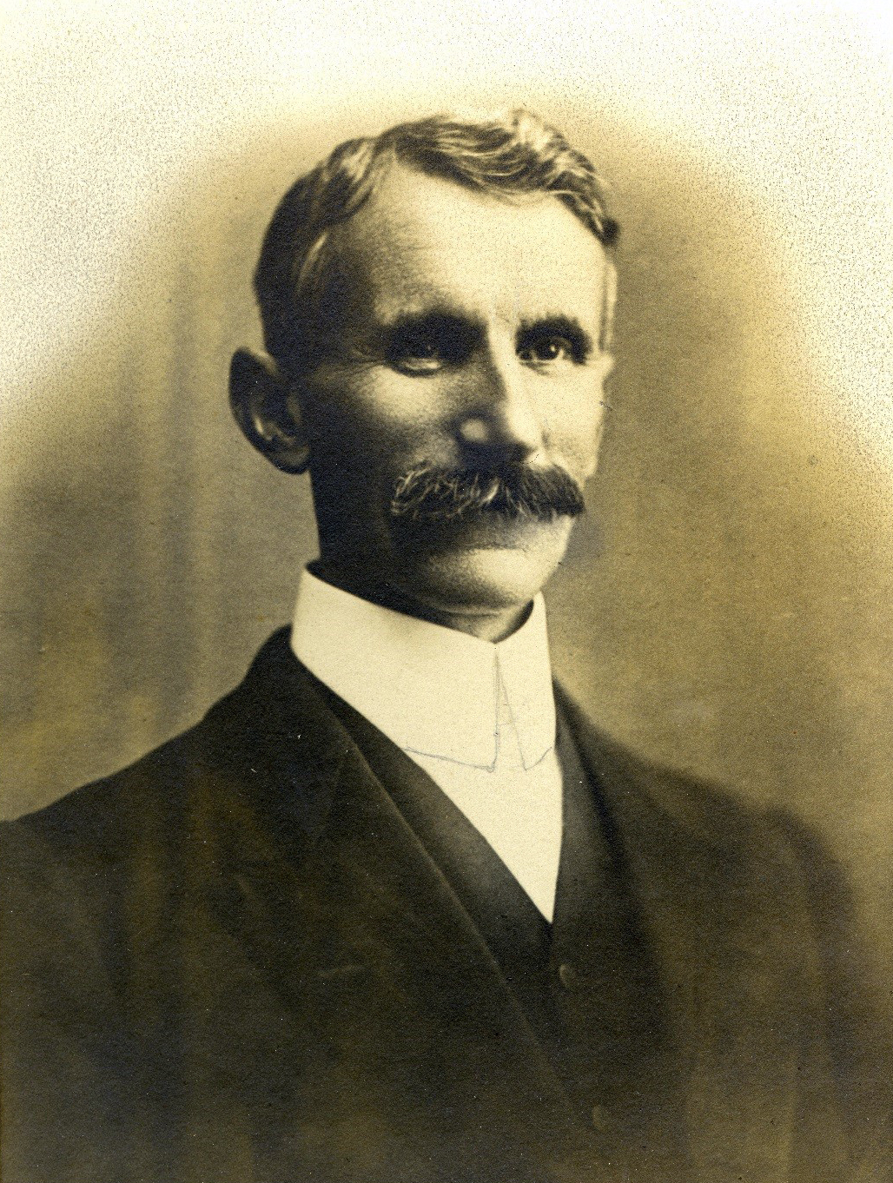
Rev. William Grant

Ministers: All the people
Liturgist: Beverley Smith
Readers: Bob Bos/Pat Flockhart
Organist: Lynne Cotton

We welcome all visitors to our service this morning.
Please sign the Visitors’ Book and make yourself known to the Hosts who stand at the back of the church.
A toilet is located in the foyer.
In our worship we use inclusive language as much as possible. Sometimes, especially in the hymns, this is not possible. Feel free to insert the language with which you are most comfortable.
BOLDED WORDS are for congregational response.
Where there is an asterisk * please stand.

Welcome and Notices

Introit: HS118
Simply to be, to be in stillness,
Simply to trust that God is here,
Simply to know the Holy Presence,
Is to be blessed:
So am I blessed.

Simply to hold the given moment,
Simply to lay concern aside,
Simply to let the heart be speaking,
Is to be blessed:
So am I blessed.

GATHERING
We gather in the shadow of 100 years of war memories,
In the shadow of 100 years of efforts for peace.
We gather in the name of a God whose will is justice,
In the name of a Christ who strove for true peace.
We gather in the presence of the Spirit whose image is a dove.
In each other’s presence, may our name be Love.

PRAYER OF APPROACH
Leader: The world belongs to God
All: The earth and all its people
Leader: How good and lovely it is
All To live together in unity
Leader: Love and faith come together
All: Justice and peace join hands
Leader: If the Lord’s disciples keep silent
All: These stones would shout aloud
Leader: Open our lips O God
All: And our mouths shall proclaim your presence.
AMEN

PRAYER FOR PEACE
God blesses those who work for peace,
For they will be called the children of God. (Matt5:9)
Silence
God of peace you call us to peace
Peace within and peace without
Peace before and peace behind
Peace on right and peace on left
Christ of peace you call us to peace.
Peace with brother and with sister
Peace with neighbour and with stranger
Peace with friend and with foe.
Spirit of peace you call us to peace.
Peace in work and in play
Peace in thought and in deed
Peace in word and in action
Grant us peace O God of peace. Amen

*HYMN: Make me a Channel of your Peace CH4 528
Make me a channel of your peace,
Where there is hatred let me bring your love;
Where there is injury, your pardon, Lord’
And where there’s doubt true faith in you.
O master, grant that I may never seek
So much to be consoled as to console,
To be understood, as to understand;
To be loved, as to love with all my soul.

Make me a channel of your peace,
Where there’s despair in life, let me bring hope;
Where there is darkness, only light;
And where there’s sadness, only joy.

Make me a channel of your peace
It is in pardoning that we are pardoned,
In giving life to all folk that we receive,
And in dying that we’re born to eternal life.

Make me a channel of your peace.
Where there is hatred let me bring your love;
Where there is injury, your pardon Lord;
And where there’s doubt, true faith in you.

Psalm 46
God is our Refuge and Strength
Contemporary Reading:- Poem –Margaret Copland
RESPONSE
For the word of God in scripture and story
For the word of God among us
For the word of God within us,
We give thanks

Offering & Dedication:

* Nun Danket CH4 182
Now thank we all our God
with hearts and hands and voices,
who wondrous things hath done,
in whom his world rejoices:
who from our mothers’ arms
hath blest us on our way
with countless gifts of love,
and still is ours today.
AMEN

CH3 527
Eternal Father, strong to save,
Whose arm hath bound the restless wave,
Who bidd’st the mighty ocean deep
Its own appointed limits keep:
O hear us when we cry to thee
For those in peril on the sea.

O Christ, whose voice the waters heard,
And hushed their raging at thy word,
Who walkedst on the foaming deep,
And calm amid the storm didst sleep.
O hear us when we cry to thee
For those in peril on the sea.

O Holy spirit, who didst brood
Upon the waters dark and rude,
And bid their angry tumult cease,
And give, for wild confusion, peace:
O hear us when we cry to thee
For those in peril on the sea.

O Trinity of love and power,
Our brethren shield in danger’s hour,
From rock and tempest, fire and foe,
Protect them wheresoe’er they go:
Thus evermore shall rise to thee
Glad hymns of praise from land and sea.

Anzac Reflection:
Reader: Overview:
Remembering Rev. William Grant: an Anzac Reflection:
Bob Bos: Letters from Gallipoli
Commemoration – we honour our very own servicemen *Please stand: Bob continues

*“The Last Post” - Please stand
*ODE of REMBRANCE:
ALL: They shall not grow old,
as we that are left grow old;
Age shall not weary them,
nor the years condemn.
At the going down of the sun
and in the morning
We will remember them.

Poppies to be placed on Rev. William Grant’s Plaque
Poppies to be placed on WW1 Remembrance Plaque

*Hymn: HS61
Honour the dead, our country’s fighting brave,
Honour our children left in foreign grave,
Where poppies blow and sorrow seeds her flowers,
Honour the crosses marked forever ours.

Weep for the places ravaged by our blood,
Weep for the young bones buried in the mud,
Weep for the powers of violence and greed,
Weep for the deals done in the name of need.

Honour the brave whose conscience was their call,
Answered no bugle, went against the wall,
Suffered in prisons of contempt and shame,
Branded as cowards, in our country’s name.

Weep for the waste of all that might have been.
Weep for the cost that war has made obscene,
Weep for the homes that ache with human pain,
Weep that we ever sanction war again.

Honour the dream for which our nation bled,
Held now in trust to justify the dead,
Honour their vision on this solemn day:
Peace known in freedom, peace the only way.
Words Shirley Murray, Music Colin Gibson.

PRAYER
An Act of Remembrance and Prayer
Let us pray for all who suffer as a result of conflict, and ask that God may give us peace.
For the servicemen and women who have died in the violence of war, each one known to God, may God give peace.
God give peace

For all members of the armed forces who are in danger this day,
Remembering family, friends and all who pray for their safe return, may God give peace.
God give peace

For civilian women, children and men whose lives are disfigured by war or terror, calling to mind in penitence the anger and hatreds of humanity, may God give peace.
God give peace

For peace-makers and peace-keepers, who seek to keep this world secure and free, may God give peace.
God give peace

For all Defence Force chaplains offering support, encouragement, acceptance, compassion and understanding, wherever and whenever it is needed, may God give peace.
God give peace
For all who bear the burden and privilege of leadership – political, military and religious; and for all who seek wisdom and resolve in the search for reconciliation, may God give peace.
God give peace

O God of truth and justice,
We hold before you those whose memory we cherish,
And those whose names we will never know.
Help us to life our eyes above the torment of this broken world,
And grant us the grace to pray for those who wish us harm.
As we honour the past, may we put our faith in your future;
For you are the source of life and hope, now and for ever.
Amen. (Source: Uniting Church in Australia)

*Hymn: Let there be peace on earth
Let there be peace on earth
and let it begin with me;
Let there be peace on earth,
the peace that was meant to be
With God our creator, we’re one family
Let us walk with each other
in perfect harmony.

Let peace begin with me,
let this be the moment now.
With ev’ry step I take,
let this be my solemn vow:
To take each moment,
and live each moment, in peace eternally.
Let there be peace on earth
and let it begin with me.

*Blessing
Blessed are those who come in peace
Who fought then and fight now for peace with justice
Go in peace and spread peace wherever you go.
We go in peace to spread peace wherever we go,
Peace founded on truth and justice and formed by Love.

*SUNG AMEN

Please join us for a time of fellowship and friendship in the lounge of the Community Centre next door for a cup of tea or coffee

Note: The offering is now received at the door as we enter. If you miss noticing this, you may place a retiring offering in the offering boxes at the door as you leave.

Mindful Prayer topics April 20th & 27th 2025 The TRUE meaning of Easter. Global turmoil. ANZAC Day and the sacrifices made. Grieving families. GPP, Parish Council and our future. Thanks to those who bring joy. Ourselves.

Christian Blind Mission accepts used stamps. Send directly to them or Val Hall. (Leprosy Mission no longer accepts stamps)

Please remember donations for the Love basket when shopping. All offerings gratefully received.

For all Pastoral care needs please contact one of the committee members:
Jenny Lawton 868 4268; Ruth McLennan 021 02704867; Jan Gordon 0211836008; Lynnor Cooke 06 214 3945; Barbara Larsen 863-9009

Matawhero Gardening happens from time to time. If you would like to help, please contact Paulina Melief 867 0605

Commission contact: Commission Convenor Rob McIntosh, email rob.mcintosh02@gmail.com, or Phone 0274411392 to arrange a time to talk further
Gisborne Presbyterian Parish
St Andrew’s Church and Matawhero Historic Church:
Office: 06 868 5513 Hours 10-12 Tuesday – Thursday
176 Cobden Street 4010 Bank A/c number 03-0638-0462917-000
standrewsgisb@xtra.co.nz www.standrewsgis.org.nz

DIARY for this week in April/May
SUNDAY 27 EASTER 2 ANZAC remembrance School Hols End
10.00am St Andrew’s followed by farewell
morning tea for David Russell.
Matawhero– no service
3.00pm Sea of Faith
Tuesday 29 10.00am Open Door
Wednesday 30 9.45am mainly music resumes
Friday 2 May 1.00pm Choir rehearsal tbc

SUNDAY 4 EASTER 3
10.00am Matawhero Communion Service
celebrant Pat Flockhart
St. Andrew’s – no service
2.00 Quang Hong Luu Piano Concert
MVG + St A’s

Coming up:
Sunday 27th April morning tea after the service to farewell David Russell. Morning tea contributions welcomed.
mainly music resumes Wednesday 30 April
4th May Pianist Quang Hong Luu plays Sonatas by Scarlatti and Liszt
Monday 2 June Piano Extravaganza XV

Sunday | Reader | Door & Team | Morning Tea | Sound Visual
12 January  Epiphany 1  Sr Cynthia Kearney | Matawhero  No service  St Andrew’s  Alvin Hall | Seton Clare  Dianne Burrows | Lyn Griffiths | S&V: Don  C:Don
Sunday 27th April  ANZAC observed  Bev Smith | M: No service  St A’s: Bob Bos | Chrissie Parker  Cathy Porter | Dianne Burrows  Farewell to David Russell. | S&V: Alan  C: Don
Sunday 4th May  Matawhero communion | M: Barbara Larsen  St A’s: No service | Matawhero Team | Matawhero Team  Contributions welcome | S&V: N/A  C: N/A
Communion elders 4th May Pat Flockhart celebrant
Jan Ewart, Barbara Larsen

