GISBORNE PRESBYTERIAN PARISH
WELCOME TO ST ANDREW’S GISBORNE

Matawhero Church – Church Lane

St Andrew’s Church and Community Centre:

176 Cobden Street, Gisborne

30 June 2024 Celebrating Matariki Pentecost 6

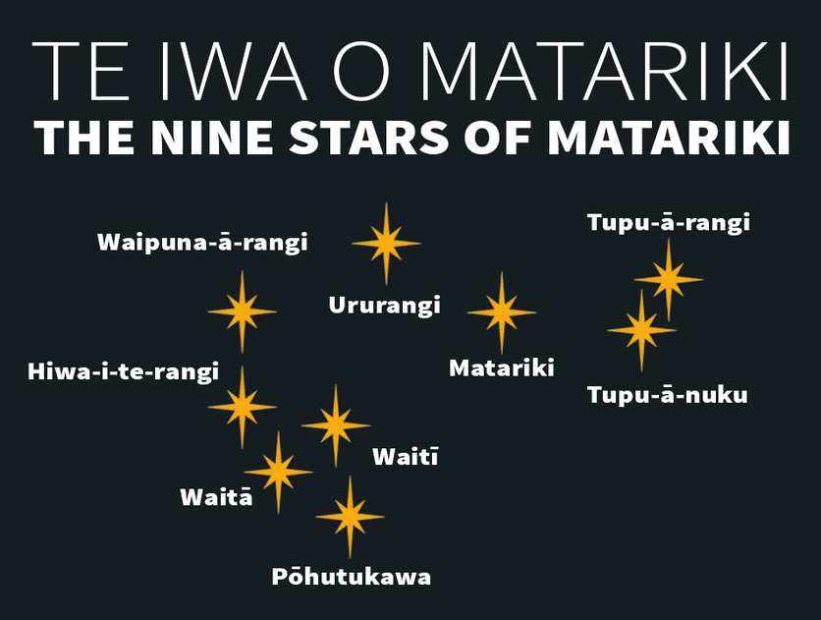

- Matariki (Alcyone) – people’s health and wellbeing
- Tupu-ā-rangi (Atlas) – things that grow in trees, including fruits, berries and birds
- Waipuna-ā-rangi (Electra) – rainfall
- Waitī (Maia) – freshwater bodies and foods from these waters
- Ururangi (Merope) – the winds
- Tupu-ā-nuku (Pleione) – food that is gathered/harvested from the soil
- Waitā (Taygeta) – the ocean and foods that come from it
- Pōhutukawa (Sterope) – those who have passed on
- Hiwa-i-te-rangi (Calaeno) – attainment of goals.
We welcome all visitors to our service this morning.
Please sign the Visitors’ Book and make yourself known to the Hosts who stand at the back of the church. A toilet is located in the foyer.
In our worship we use inclusive language as much as possible. Sometimes, especially in the hymns, this is not possible. Feel free to insert the language with which you are most comfortable. BOLDED WORDS are for congregational response. Where there is an asterisk * you are invited to stand.

Greetings with news and notices
Introit and entry of Bible Simply to be HS 118

Simply to be, to be in stillness,
simply to trust that God is here,
simply to know the Holy Presence,
is to be blessed: so am I blessed,

simply to hold the given moment,
simply to lay concern aside,
simply to let the heart be speaking,
is to be blessed: so am I blessed,

Call to Worship :
Adapted from Psalm 8 by Rev Dr CB Yates
L : When I look at the night sky and see the work of your fingers—
the moon and the stars you have set in their place --
All : What are we -- mere mortals that You should think about us?
We human beings --that You should care for us ?

L : Yet you made us only a little lower than God --
and crowned us with glory and honour.
You gave us charge of everything you made,
putting all things under our authority --
All : All of the flocks, and all the herds, and all the wild animals,
All the birds which fly in the sky, All the fish that swim in the seas;
Even the grass and grains that grow in our fields:
O Lord; our LORD: Your majestic Creation fills the earth!
Amen.
Opening Prayer

*We Sing: Praise the Lord, you heavens adore him CH4 139 Tune 738
Praise the Lord! ye heavens, adore him; T: Austrian Hymn
Praise him, angel, in the height;
Sun and moon, rejoice before him,
Praise him, all ye stars and light.
Praise the Lord! for he hath spoken;
Worlds his mighty voice obeyed;
Laws which never shall be broken
For their guidance hath he made.

Praise the Lord! for he is glorious;
Never shall his promise fail;
God hath made his saints victorious;
Sin and death shall not prevail.
Praise the God of our salvation!
Hosts on high, his power proclaim;
Heaven, and earth, and all creation,
Laud and magnify his Name.

Children’s Chat The Little Kiwi’s Matariki by Nikki Slade Robinson

Scripture Reading: Genesis 1: 1-8; 14-19; 31 NIV
1 In the beginning God created the heavens and the earth. ² Now the earth was formless and empty, darkness was over the surface of the deep, and the Spirit of God was hovering over the waters.
³ And God said, “Let there be light,” and there was light. ⁴ God saw that the light was good, and he separated the light from the darkness. ⁵ God called the light “day,” and the darkness he called “night.” And there was evening, and there was morning—the first day.
⁶ And God said, “Let there be a vault between the waters to separate water from water.” ⁷ So God made the vault and separated the water under the vault from the water above it. And it was so. ⁸ God called the vault “sky.” And there was evening, and there was morning—the second day.
vv14-19
¹⁴ And God said, “Let there be lights in the vault of the sky to separate the day from the night, and let them serve as signs to mark sacred times, and days and years, ¹⁵ and let them be lights in the vault of the sky to give light on the earth.” And it was so. ¹⁶ God made two great lights—the greater light to govern the day and the lesser light to govern the night. He also made the stars. ¹⁷ God set them in the vault of the sky to give light on the earth, ¹⁸ to govern the day and the night, and to separate light from darkness. And God saw that it was good. ¹⁹ And there was evening, and there was morning—the fourth day.
v31
³¹ God saw all that he had made, and it was very good. And there was evening, and there was morning—the sixth day.

*We Sing: The spacious firmament on high CH4 Tune 639i
The spacious firmament on high,
with all the blue ethereal sky,
and spangled heavens, a shining frame,
their great Original proclaim.
The unwearied sun, from day to day,
does his creator’s power display,
and publishes to every land,
the work of an almighty hand.

Soon as the evening shades prevail,
the moon takes up the wondrous tale,
and nightly to the listening earth
repeats the story of her birth;
while all the stars that round her burn,
and all the planets, in their turn,
confirm the tidings, as they roll,
and spread the truth from pole to pole.

What though in solemn silence all
move round the dark terrestrial ball?
What though no real voice nor sound
amidst their radiant orbs be found?
In reason’s ear they all rejoice,
and utter forth a glorious voice,
for ever singing, as they shine,
“the hand that made us is divine.”

Reflection: Good Heavens

Intercessory Prayer

*Presentation of Offering and Dedication
Praise God from whom all blessings flow;
praise God, all creatures high and low;
give thanks to God in love made known:
Creator, Word and Spirit, One.

*We Sing: How Great Thou Art CH4 154

O Lord my God! When I in awesome wonder
Consider all the works thy hand hath made;
I see the stars, I hear the mighty thunder
Thy pow’r throughout the universe displayed;

Then sings my soul, my Saviour God, to Thee
How great thou art! How great thou art! (2x)

When through the woods and forest glades I wander,
and hear the birds sing sweetly in the trees,
When I look down from lofty mountain grandeur
And hear the brook, and feel the gentle breeze,
Refrain
And when I think that God, His Son not sparing
Sent Him to die, I scarce can take it in
That on the cross, my burden gladly bearing
He bled and died to take away my sin
Refrain

When Christ shall come with shout of acclamation
And take me home, what joy shall fill my heart!
Then shall I bow in humble adoration
And there proclaim ‘My God, how great thou art’
Refrain

*Concluding Prayer and Blessing
*Aaronic Blessing Numbers 6:24 CH4 796
The Lord bless you and keep you;
the Lord make His face to shine upon you; and be gracious unto you. The Lord lift up His countenance upon you and give you peace.

Sing: AMEN x3 CH4#819

Ministers: All the people in Christ Leader: Val Hall
Reader: Lynnor Cooke

Please join us for a time of fellowship and friendship over a cup of tea or coffee in the Lounge next door.

Note: The offering is now received at the door as we enter. If you miss noticing this, you may place a retiring offering in the offering boxes at the door as you leave.

Mindful Prayer topics: June 30th & July 7th 2024 “Let there be Peace on earth and let it begin with me” (Sy Miller/Jill Jackson). The bereaved; those undergoing health issues; medical staff. Governing bodies – global, national and local. Presbytery, GPP and Parish Council and decisions to be made..
.Mindful Prayer contact Margaret Graham ph. 021 026 03990 or email m.n.e.gra@xtra.co.nz

Christian Blind Mission accepts used stamps. Send directly to them or Val Hall. (Leprosy Mission no longer accepts stamps)

Please remember donations for the Love basket when shopping. All offerings gratefully received.

Val Hall and Pat Flockhart are offering Home Communion, and they need an Elder to be present. Any Elders willing to assist, please phone or email Val Hall.
For all Pastoral care needs please contact one of the committee members:
Jenny Lawton 868 4268; Ruth McLennan 021 02704867; Jan Gordon 0211836008 Annette Ormiston 0275535028 Barbara Larsen 863-9009
With blessings from the Pastoral Committee

DIARY

SUNDAY 30 PENTECOST 6 Matariki Observed
10.00am St. Andrew’s
Matawhero – no service
Monday 1 9.00am Walking Group
Tuesday 2 10.00am Open Door All welcome
Wednesday 3 9.45am mainly music final for term 2
Friday 5 1.00pm Choir rehearsal

SUNDAY 7 PENTECOST 7 Winter School Holidays start
10.00am Matawhero Communion Service
St. Andrew’s – no service

Sunday | Reader | Door & Team | Morning Tea | Sound Visual
30th June  Pentecost 6  Matariki Observed | Matawhero  No service  St Andrew’s  tbc | Seton Clare  Linda Savage, Marilyn Matthews | Trish Kwak, Ruth McLennan | S&V: Hans  C:Hans
7th July  Pentecost 7  Communion  Celebrant Pat Flockhart | Matawhero  Paulina Melief  St Andrew’s  No service | Matawhero Team | Matawhero Team  Contributions welcome | N/A

Communion Elders: Celebrant Pat Flockhart: Jan Ewart, Barbara Larsen
Gisborne Presbyterian Parish
St Andrew’s Church and Matawhero Historic Church:
Office: 06 868 5513 Hours 10-12 Tuesday – Thursday
176 Cobden Street 4010 Bank A/c number 03-0638-0462917-000
standrewsgisb@xtra.co.nz www.standrewsgis.org.nz

