GISBORNE PRESBYTERIAN PARISH
WELCOME TO MATAWHERO CHURCH

20 November 2022 Reign of Christ

Service of Worship

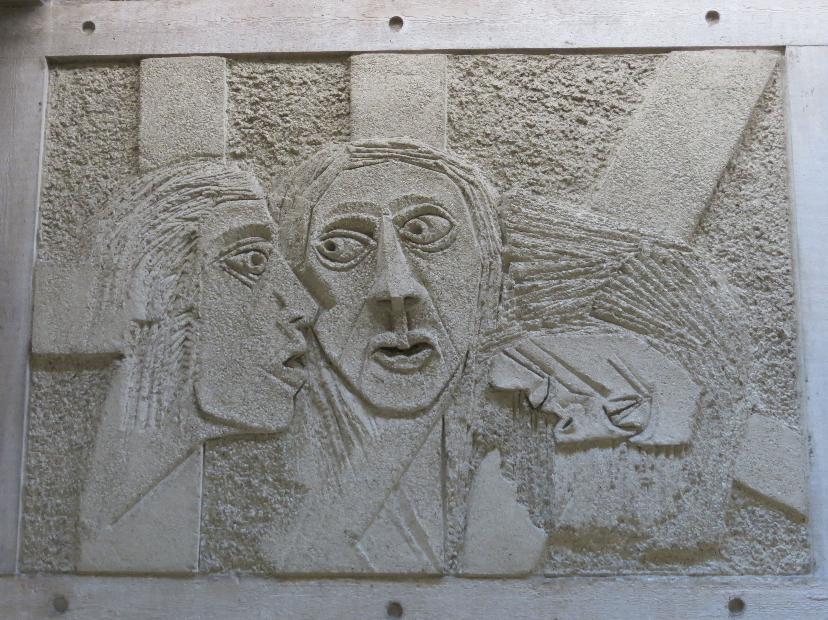

Jesus forgives the repentant theif by William Mitchell

Minister: Rev Jin Sook Kim
Reader: Wendy Johnstone Director of Music: Catherine Macdonald

Greetings with news and notices
We gather together as the people of God
Kia Ora, Talofa, Bula, Shalom, Dobry den and Annyeong-haseyo

Call to Worship
Great is the Lord!
God has redeemed God’s people!
Let the heavens shout with joy!
Let all the people celebrate God’s awesome love!
Shout and sing praise to God!
For God has healed and restored God’s people.
Hallelujah!
Hallelujah!

We sing - All glory, laud and honour, Harmonisation: ©Oxford University Press, CH3 233 vv1-5

Prayers

We sing – Jesus shall reign where’er the sun, CH3 413, vv1-4

Reading
Gospel Reading – Luke 23:33-43
(The theme is reign of God on the cross)
Question: What did God do to exercise God’s sovereign power here?
(a minute of silence)
Reading Luke 23:33-43 again
Question: What does reign of God mean for you?

(Reflecting your life in silence for one minute)

Sharing: What is God doing to exercise God’s sovereign power in your life, (and in church)?
(After sharing, a minute of silence)

Prayers of Intercession

Offering

We sing - Ye servants of God, your master proclaim, CH3 371, vv1-4

Sending
The Grace
Kia tau ki a tātou katoa
Te atawhai o tō tātou Ariki, a Ihu Karaiti Me te aroha o te Atua
Me te whiwhingatahitanga, Ki te wairua tapu
Ake, ake, ake
Amine
The Grace of our Lord Jesus Christ, the love of God and the fellowship of the Holy Spirit be with us all, now and forever.

Sing: AMENx3 CH4#819

