GISBORNE PRESBYTERIAN PARISH
WELCOME TO ST ANDREW’S GISBORNE

Matawhero Church – Church Lane

St Andrew’s Church and Community Centre:

176 Cobden Street, Gisborne

25 September 2022 Pentecost 16

Celebration Potluck Service

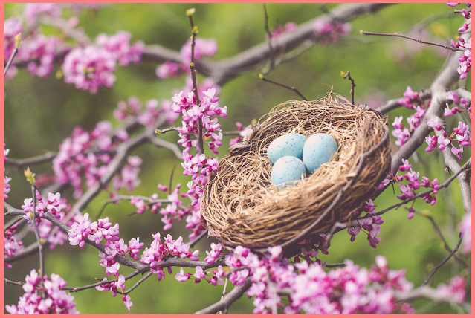

Ministers: All the people in Christ Minister: Rev Jin Sook Kim
Director of Music: Catherine Macdonald

We gather together as the people of God
Kia Ora, Talofa, Bula, Shalom, Dobry den and Annyeong-haseyo

Greetings with news and notices

Call to Worship

We invite the cosmos to worship with us.
We invite glittering galaxies high in the sky
to radiate the splendour of God’s presence.

We summon that piece of stardust called Earth,
To pulse with the rhythm of God’s presence
and celebrate God’s glory in this planet garden.

We invite millions of living species to dance with life,
The turtle, the toad and the elephant,
the earthworm, the ant and the dragonfly.

We invite every creature in the web of creation
To consciously connect with others
in this community called the cosmos.

Dance, creation, dance!
Dance with cosmic energy!

We sing - All my hope on God is founded, CH4 192, TUNE: GROESWEN, vv1-5

All my hope on God is founded,
all my trust he will renew;
safe through change and chance he guides me,
only good and only true.
God unknown,
he alone
calls my heart to be his own.

Human pride and earthly glory,
sword and crown betray God’s trust;
though with care and toil we build them,
tower and temple fall to dust.
But God’s power,
hour by hour,
is my temple and my tower.

God’s great goodness lasts for ever,
deep his wisdom passing thought:
splendour, light, and life attend him,
beauty springing out of naught.
Evermore,
from his store
new-born worlds rise and adore.

Day by day the mighty Giver
showers gifts on us below;
his desire our souls delight in,
pleasure leads us where we go.
See love stand
at his hand,
joy awaits at his command!

Still from earth to God in heaven
sacrifice of praise be done,
high above all praises praising
for the gift of Christ his Son.
Hear Christ call
one and all:
those who follow shall not fall.

Prayers
We confess that we have striven to discover other world,
while polluting our own atmosphere and
ignoring the needs of others
with whom we are closely connected
in that part of the web of creation
called planet Earth.

We are sorry.
We have polluted Earth’s atmosphere
and cut a hole in the ozone layer.
We have turned our greed into global warming.
We have ignored our crucial connection
with those parts of creation where we live.
We are loved progress more than the planet.
We are sorry. We are sorry.

We are sorry.
We are sorry. We are sorry.

Words of Pardon

Christ hears our confession
and forgives our sins
against your part of the cosmos community.
We celebrate Earth as our home
a precious piece in the web of creation.

Celebration Time
Celebrations today
May God bless you, we pray
Live for Jesus dear people
May He guide you each day
Activities

Story Time
We sing – Give thanks for life, Words © 1987 Hope Publishing Company, CH4 736, vv1-4

Give thanks for life, the measure of our days,
mortal, we pass through beauty that decays,
yet sing to God our hope, our love, our praise:
Alleluia, Alleluia!

Give thanks for those whose lives shone with a light
caught from the Christ-flame, gleaming through the night,
who touched the truth, who burned for what is right,
Alleluia, Alleluia!

Give thanks for all, our living and our dead,
thanks for the love by which our life is fed,
a love not changed by time or death or dread:
Alleluia, Alleluia!

Give thanks for hope that, like the seed of grain
lying in darkness, does its life retain
to rise in glory, growing green again:
Alleluia, Alleluia!

Reading - Colossians 1:15-20

Reflection

Anthem – The spring has come, Words © Shirley Murray Tune: Vervacity © Colin Gibson Alleluia Aotearoa 140, vv1-3

The spring has come, let all the Church be part of it!
The world has changed, and God is at the heart of it!
New light, new day, new colour after winter grey.
New light, new day, the spring has come,
let all the Church be part of it!

The sun is warm, let all God’s children play in it!
The world expands, let’s spread the Gospel way in it!
New leaf, new thrust, new greening for the love of Christ.
New leaf, new thrust, the sun is warm,
let all God’s children play in it!

The spring has come, new people are the flowers of it.
Through wind and rain, new life is in the showers of it.
New bud, new shoot, new hope will bear the Spirit’s fruit.
New bud, new shoot, the spring has come,
new people are the flowers of it!

Offering (and Guardian Angel)

We sing - Spring has now unwrapped the flowers, © Oxford Book of Carols 99
1. Spring has now unwrapped the flowers, day is fast reviving,
life in all her growing powers towards the light is striving:
gone the iron touch of cold, winter time and frost time,
seedlings, working through the mould, now make up for lost time.

2. Herb and plant that, winter long, slumbered at their leisure,
now bestirring, green and strong, find in growth their pleasure:
all the world with beauty fills gold the green enhancing;
flowers make glee among the hills, and set the meadows dancing.

3. Through each wonder of fair days God’s own self expresses;
beauty follows all God’s ways, as the world God blesses:
so, as God renews the earth, artist without rival,
in God’s grace of glad new birth we must seek revival.

4. Earth puts on her dress of glee; flowers and grasses hide her;
we go forth in charity - gathered all beside her;
for, as we this glory see, in the awakening season,
reason learns the heart's decrees, and hearts are led by reason.

5. Praise the Maker, all ye saints; God with glory girt you,
and who skies and meadows paints fashioned all your virtue;
praise God, seers, heroes, kings, heralds of perfection,
people, praise then, for God brings all to resurrection!

Sending
The Grace

Kia tau ki a tātou katoa
Te atawhai o tō tātou Ariki, a Ihu Karaiti Me te aroha o te Atua
Me te whiwhingatahitanga, Ki te wairua tapu, Ake, ake, ake
Amine

The Grace of our Lord Jesus Christ, the love of God and the fellowship of the Holy Spirit be with us all, now and forever.

Sing: AMENx3 CH4#819

